Introduction

CHAOSS AUGUR is an open source software that can track the health and sustainability of any open source software.

Overview

Augur allows users to look at contribution graphs and comparisons to other data sets as well as time stamps on commits so every aspect can be tracked. This data is available to all users and contributors. This allows those involved to have more informed decisions when working in open source projects.

Data can be contributed, distributed, updated, and examined before action is taken. This sets a standard for open source projects.

System use

Developers – user that programs on/with open source software and uses CHAOSS to track their project

Investor – stakeholder in open source projects who want to track progress

CHAOSS dev – user that commits code to improve upon CHAOSS

Mangers – uses system data to track the health of projects

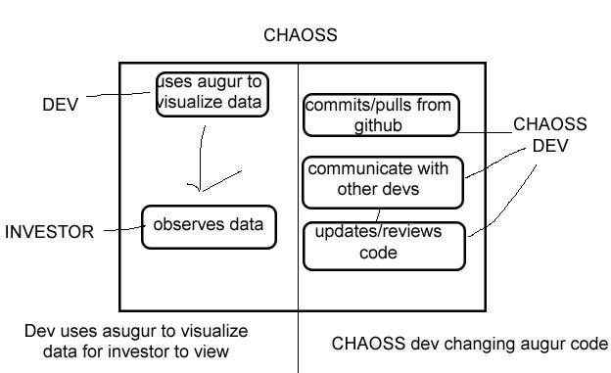

Functional specification

Data for visualization should be obtainable

Metrics for open source software should be attainable for view of system health

Storage should be able to handle size of various projects

All necessary info about augur should be available to users

Non-functional specification

Augur should be user friendly and easy to navigate

Should always be reliable and available to users

Follow any relative regulations

Design constraints

Will have to work with various hardware/software

Program language constraints

Web page compatibility

Veracity of submitted data

Different programming styles and standards from devs

Purchased components

Personal machine

Dev server for testing

Interface

Sorted and organized by user and projects

Metric to display commits

Contributors